**GLOCERY STORE**

***Undertaken By:***

**[MUHAMMAD FAHAD BHUTTA]**

**Reg. No. CIIT/FA19-bSE-033/Vehari**

***Supervisored By:***

**[SIR ZAHID ANWER]**



**DEPARTMENT OF COMPUTER SCIENCES**

**COMSATS UNIVESITY ISLAMABAD, VEHARI CAMPUS**

**Vehari – PAKISTAN**

**Project Title:**

Grocery Store

**Summary:**

Almost everything has now been automated. From completing our everyday duties to amusement and leisure, transactions, and other things that we engage in regularly. This research focuses on grocery automation. Traditionally, people go to grocery stores to buy groceries, which is inconvenient. They frequently spend hours shopping for groceries and exert much effort in navigating the supermarkets in search of the items they require. They must also wait in long lines to pay for their purchases, which take a long time. This technique of grocery shopping needs reform, and this is where the technology may help. Nowadays, most people rely on their cell phones for a variety of reasons. Smartphones come pre-loaded with a variety of mobile apps that are handy in everyday life. Apps have simplified several tasks for customers. We can’t deny that individuals nowadays lead stressful lifestyles. Every other person chose the shortest way to perform a task. The study’s researchers advised developing a supermarket application that is specifically built for electronically purchasing fruit foods. The researchers will design the application with flutter, a cross-platform technology used to develop android and iOS applications. End-users will be able to buy fruit goods online, making it easier and more convenient. It will not be necessary for them to spend significant time and effort simply going to grocery stores to get fruits. Users who want to effortlessly shop for fruits can easily download and utilize the application.

**Introduction:**

Today’s technology has made a significant contribution to people’s daily routines and regimens. Individuals’ lives and jobs are made easier by technology. The capstone project, “Fruit Grocery App in Flutter,” is a fruit grocery automation application.

Technology also makes it easier for people to accomplish specialized duties in the home. With great minds designing something only to enable easy and quick performance for that duty to be completed. In terms of fruit grocery shopping, people are still used to visiting grocery stores to buy the meals fruits that they need.

**Objectives:**

**General Objective** – the researchers of the study aim to design, develop, and implement a fruit grocery application developed using Flutter.

1. To develop an application for fruit grocery automation.
2. To transition the traditional fruit grocery process to an electronic one.

## ****Scope:****

## The application, they won’t need to personally visit grocery stores just to buy fruits. The application will help them save more time and effort. The target users of the system are grocery stores and their clients.

## Functionality:

## People have a basic need to purchase foods and essential household products all the time, it is a challenge for retailers and managers to find out those needs and also to encourage customers to buy more of what is might be less important so that the company can gain more profit in each shopping period.

## ****How the System Works****

**Screen with Details Description:**

**Welcome Screen:**

**Detail:** The module is welcome screen. Welcome screen is get Started Button.

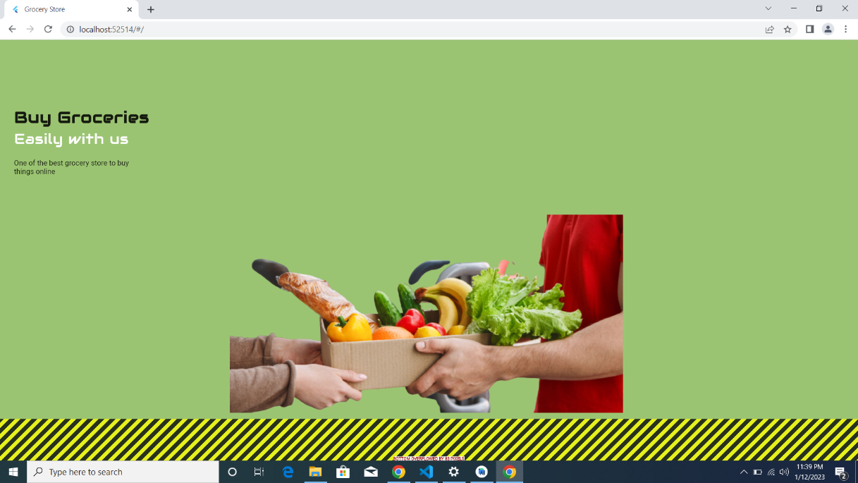

**Login Screen/Signup page:**

**Details:**

Then about the screen itself, Sign in. Now, we have two text fields, user name and password, to get login/sign-in credentials from user.

Login page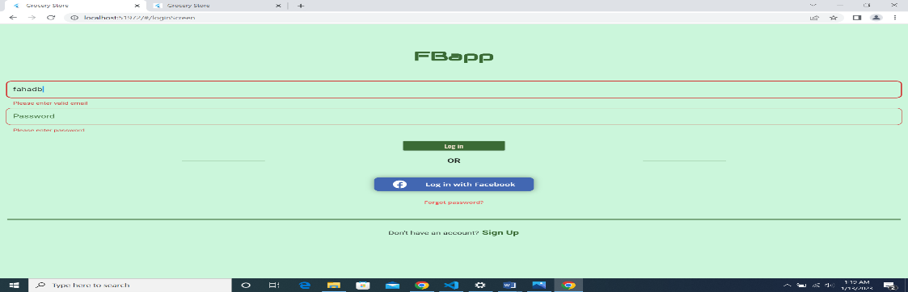

Sign up page:

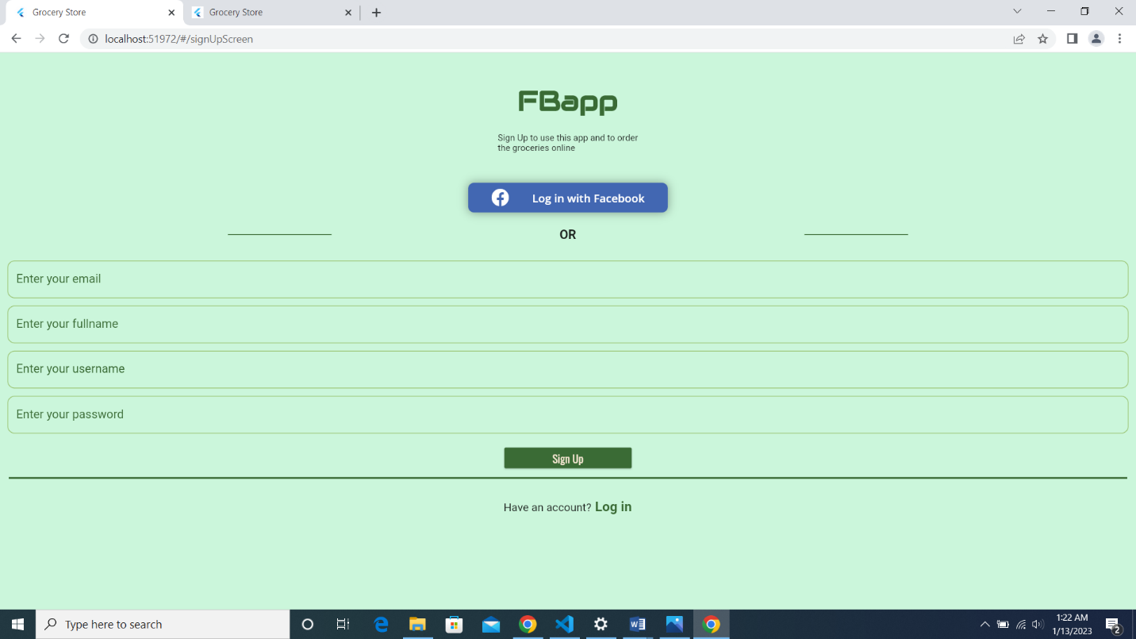

**Profile Screen Page**

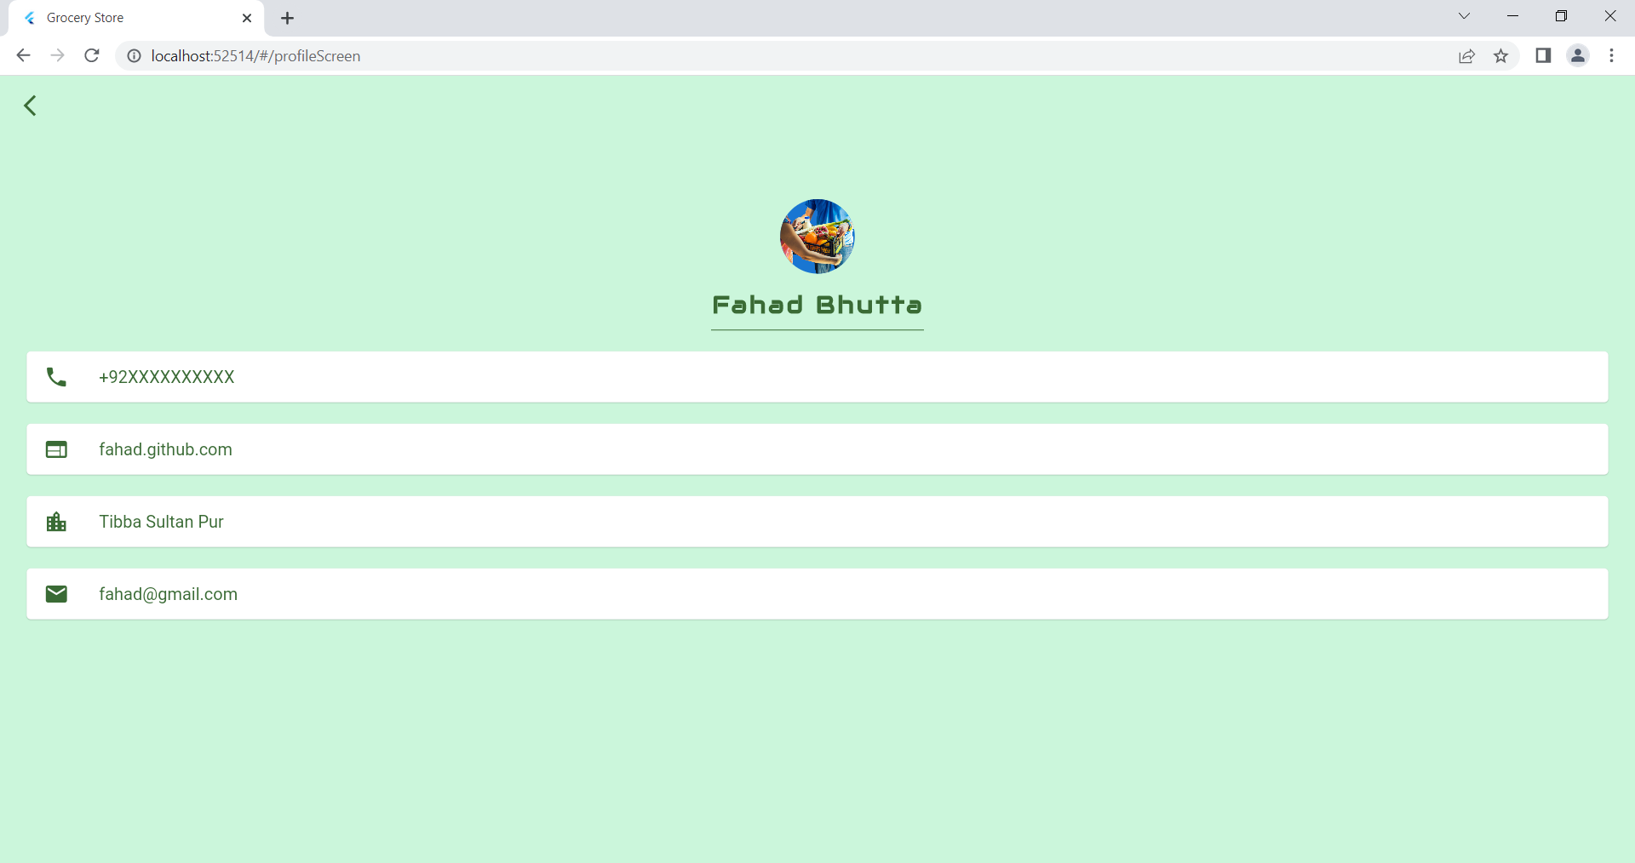

**Detail:**

My detail

* + - Call
    - GitHub id
    - Address
    - Email

**Draw Page:**

Detail

list Side

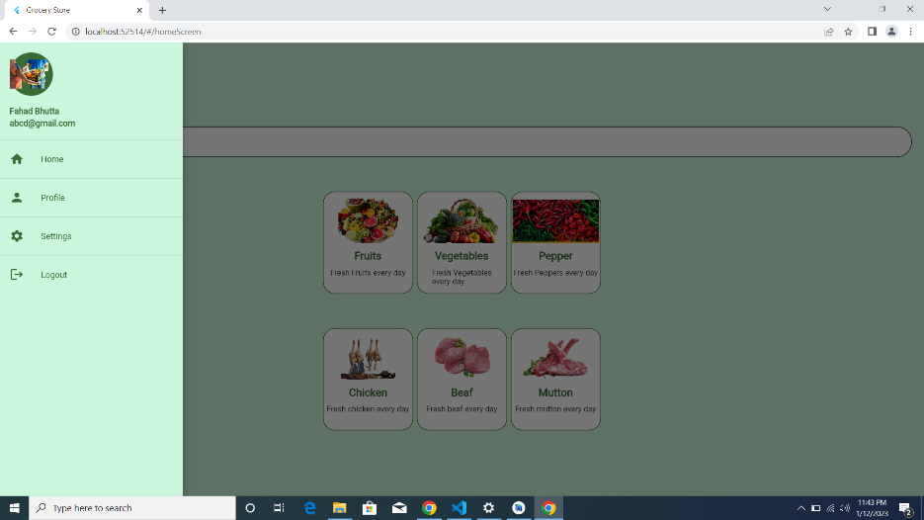

**Home page:**

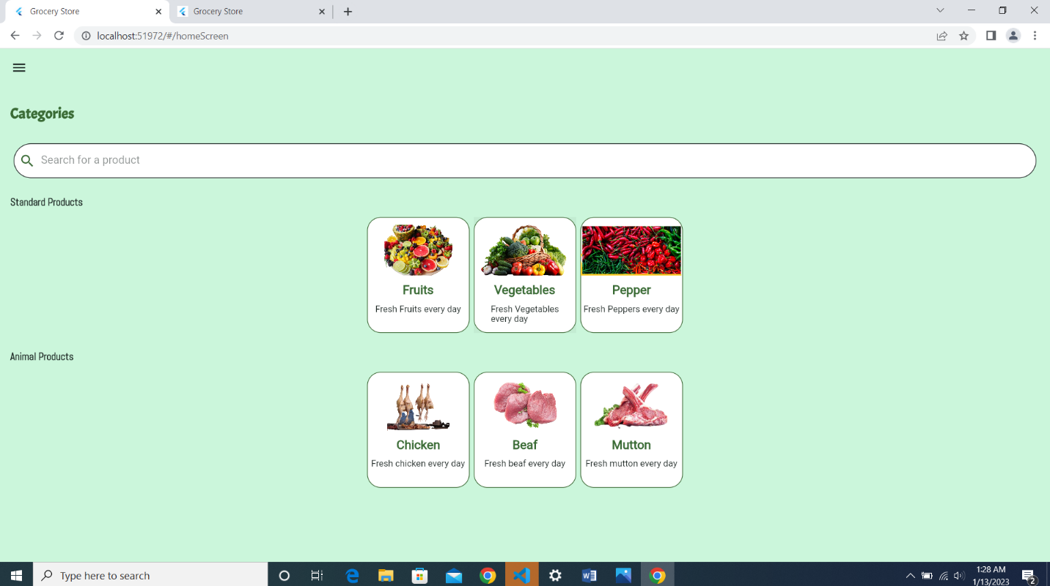

**Categories:**

* Standard Product
* Animal product

**Standard Product:** 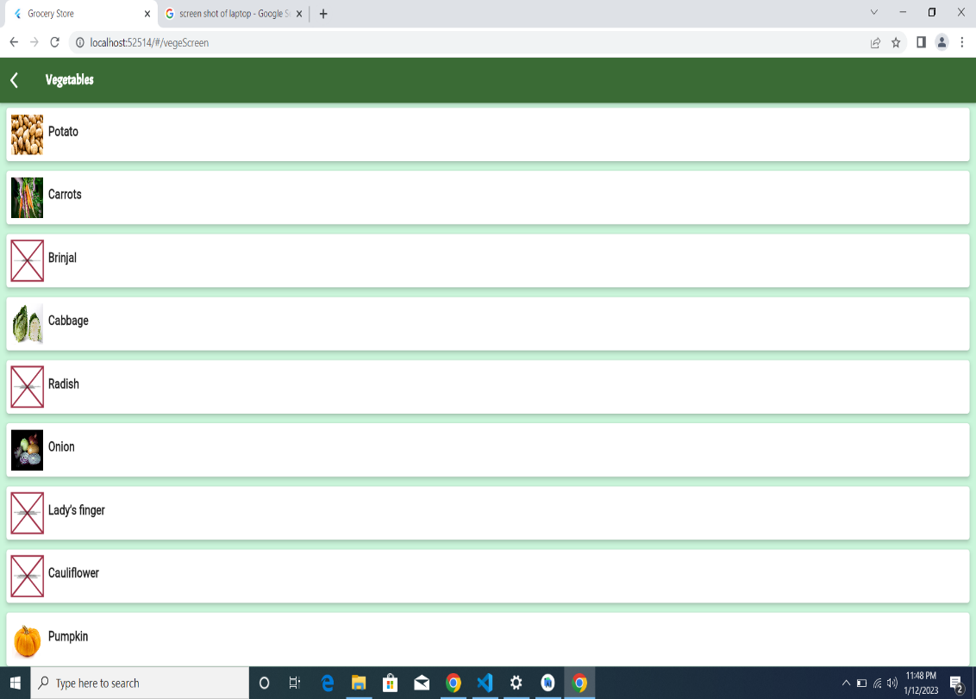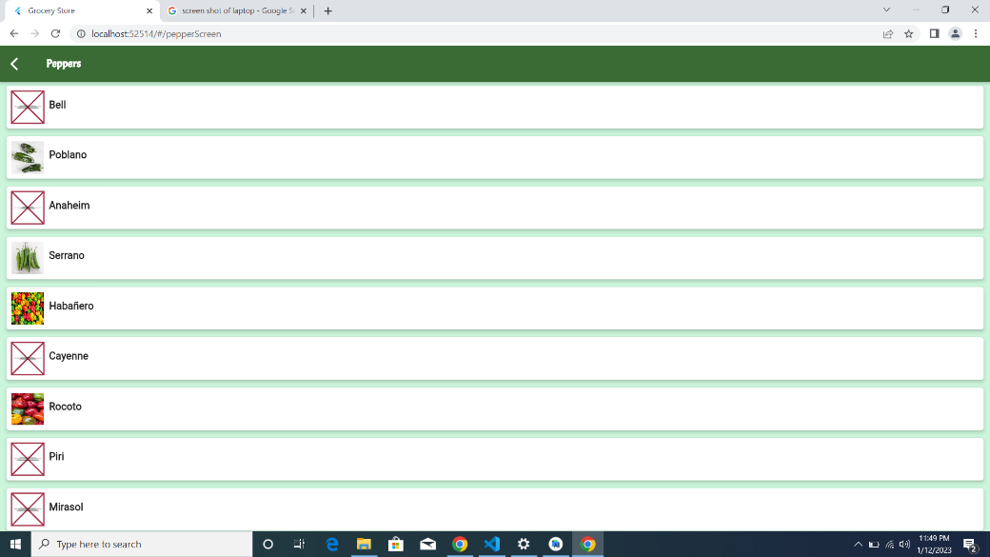

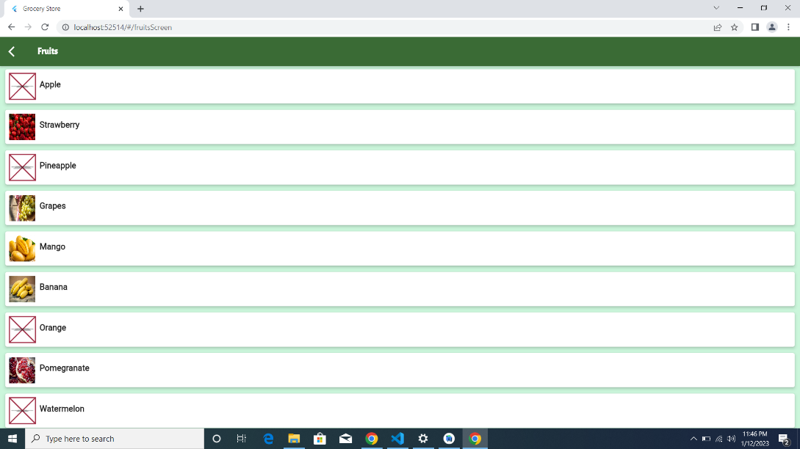

**Animal Product**